GEORGETOWN UNIVERSITY
DEPARTMENT OF CLASSICS
SPRING 2019

CLASSICAL STUDIES 285

SLAVERY IN THE ANCIENT MEDITERRANEAN

MW 3:30 – 4:45 P.M. Zachary Herz, 318 Healy
Walsh 391 zh149@@georgetown.edu
Office Hours: {TBD}

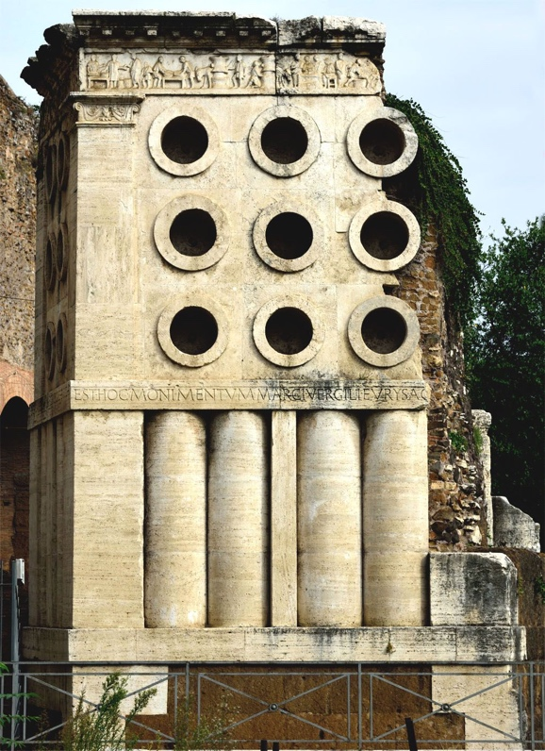

Tomb of Eurysaces the baker. Image via Wikimedia Commons.

Course Description:

The ancient Mediterranean’s farms, palaces, and markets (to say nothing of its brothels) were staffed by enslaved people; slave labor formed the backbone of the ancient world as we know it. This course attempts to better understand the people who kept Greece and Rome running, often under conditions of brutal exploitation. We will do so by examining a variety of sources; while enslaved voices are rarely preserved directly, we can see their traces everywhere in ancient culture. Students will not only learn about how enslaved people lived their lives in the Greek and Roman worlds, but will also think through the methodological problems inherent in studying nonelites through records of elite activity. Students will be tested on this material with a midterm exam and with a short and a long paper.

Classes:

Class will be a mixture of lecture and discussion, weighted towards the latter. Students are expected to arrive every day prepared to discuss questions and methodological problems raised by the reading. Some of the readings for this class will be disturbing—I don’t want to give a rose-colored view of this aspect of the ancient world—and in such cases I will warn you in advance in case you prefer to do those readings privately.

Assignments and Grading:

Students will be graded on participation, in addition to a midterm exam and two papers. Grades will be calculated as follows:

Midterm: 25%
Short Paper: 25%
Long Paper: 30%
Participation: 20%

I reserve the right to depart from this rubric in extraordinary circumstances, but rarely do so.

Classroom Conduct:

I expect students to remain attentive and respectful at all times, particularly of each other. While I do not expect to cold call, I do expect all of you to help me create as comfortable a space for open dialogue as possible.

I strongly prefer that students not use personal computers in class. Students with electronic editions of texts may use an e-reader (preferred) or laptop, but I will ask that any devices be disconnected from the internet during class time. Students who require laptops or other note-taking devices as a matter of accommodation should contact the Academic Resource Center (ARC).

Disability and Accommodation:

As a Georgetown student, you are entitled to reasonable disability accommodations under the Americans with Disabilities and Rehabilitation Acts. However, you also have strong privacy rights under the Family Educational Rights and Privacy Act, which forbids me from asking you questions about your medical history in order to evaluate an accommodations request. Like many universities, Georgetown has created a special office to address accommodation requests within ARC.

In order to receive disability-related academic accommodations, you must first be registered with ARC, who will walk you through the process of requesting accommodation. Please do not come to me directly with accommodation requests—I will gladly honor such requests from ARC, but cannot evaluate and accommodate students myself.

Academic Honesty:

I expect you to adhere to Georgetown’s Honor Code and am affirmatively responsible for reporting suspected infractions. If you plagiarize, I will catch you, and I am mean. That said, the rules around plagiarism and academic honesty are not always intuitive; if you are not sure how best to cite a source or what sort of attribution is appropriate, bring the source to office hours or make an appointment to discuss it. I’m happy to help you stay out of trouble.

Required Texts:

The following texts are available at the Georgetown University bookstore. If you prefer to save some money, or alternately to contribute to America’s once thriving and now critically endangered independent book sellers, mazel tov; however, please make sure you have purchased the most recent edition.

Wiedeman, Greek and Roman Slavery. Taylor. ISBN: ISBN: 9780415029728.
Joshel, Slavery in the Roman World. ISBN: 9780521535014.
Andreau, Slavery in Greece and Rome. University of Wisconsin Press.
ISBN: 9780299283742.

Schedule of Topics and Reading Assignments:

All readings for a given week should be completed by class on that Monday. These readings may be supplemented with short readings on more contemporary topics. All readings not in one of the required texts for this class will be made available on Canvas.

Class 1: Introduction

Unit I: Greek Slavery

Week 1: Mycenaean Slaves & Servants (Andreau, 19-25; Iliad VI.461-600; Odyssey XIV.1-108)

Week 2: Athens and Laurion (Ismard, Democracy’s Slaves (selections); Wiedemann 15-21, 190)

Week 3: Slaves, Helots, & The Spartan Mirage (Rahe, The Grand Strategy of Classical Sparta (selections); Wiedemann 88-89)

Week 4: Slaves in Greek Thought (Wiedemann 101, 177, Andreau 7-17)

Unit II: Roman Slavery

Week 5: Slaves in Roman Comedy (Plautus, Bacchides, Joshel 29-77)

Week 6: Republican Debt Exploitation (Wiedemann 36-42)

Week 7: SPARTACUS! (Appian, selections)

Week 8: Libertas & Slavery as an Idea (Dio on Augustus, Tacitus 14.42-45, Andreau 95-136)

Week 9: Penal Slavery & Executions (Digest (selections), Kathleen Coleman, Fatal Charades)

Week 10: The Freedman (Henrik Mouritsen, The Freedman in the Roman World (excerpts))

Week 11: Slave Demography (Walter Scheidel, Quantifying the Sources of Slaves in the Early Roman Empire; Joshel 111-61, Andreau 40-66)

Week 12: Slavery in Imperial Biography (Suetonius, Claudius and Nero)

Week 13: Slavery in Technical Literature (Columella, De Re Rustica (selections); Cato, De Agri Cultura (excerpts); Wiedemann 147-49)

Week 14: Slaves in Their Own Words? (Petronius, Satyricon (excerpts), images of graffiti and enslaved epigraphy)

Week 15: Slavery in Roman Law (Digest (excerpts))

Summation

