GEORGETOWN UNIVERSITY
DEPARTMENT OF CLASSICS
FALL 2018

Classics 345

Marketing Empire

Wednesday, 3:30-6:00 P.M. Zachary Herz, 318 Healy
Healy 321 zh149@@georgetown.edu
Office Hours: W 1-3 PM

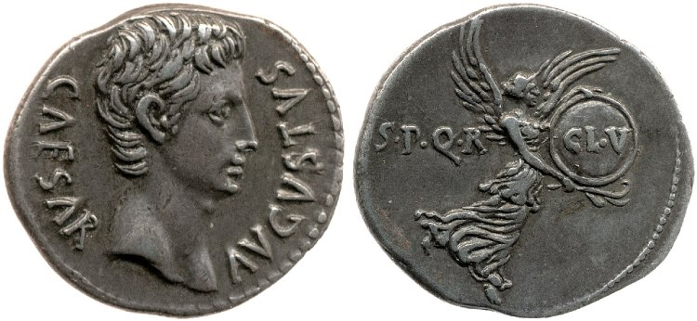

Silver denarius of 18 B.C.E. Obverse: Portrait of Augustus. Reverse: Victory in Flight. British Museum R.6079.

Course Description:

Why obey an emperor? The Roman state answered that question in two ways: one obvious—otherwise he’ll kill you—and one not. Throughout the Principate, the state encouraged obedience with ruthless force, but also with constant propaganda. Emperors were portrayed as benevolent, divinely favored paragons of virtue; their subjects, as loyal citizens collaborating with their ruler on projects of imperial greatness. This seminar will examine the theory and practice of Roman propaganda. Students will read secondary sources on theories of state communication and legitimation, while examining primary sources in a variety of different media to see how Rome and its emperors marketed themselves. In addition, students will develop a major research project focusing on one aspect of imperial self-representation and legitimation. Students will be in touch with me throughout the semester as we shepherd the project to its conclusion; I will read and evaluate thesis statements, annotated bibliographies, outlines, and drafts.

Classes:

Each class meeting will consist of a discussion of that day’s readings, with reference to ancient (and occasionally modern) examples of the phenomena there described. I expect all students to come prepared and ready to talk; towards that end, students will turn in a half-page response (via Canvas) by noon on each class day. As the semester goes on and students begin to research and write their seminar papers, students are encouraged to use examples from those papers in class. The last four sessions will be given over to paper presentations.

Assignments and Grading:

Students are expected to participate actively in discussion, to write short responses prior to each class, and to write a 15-20 page paper over the course of the semester. Grades will be calculated as follows:

Participation/Responses: 50%
Final Paper: 50%

I reserve the right to depart from this rubric in extraordinary circumstances, but rarely do so.

Classroom Conduct:

I expect students to remain attentive and respectful at all times, particularly of each other. Because you and your colleagues will have to speak extemporaneously, I expect all of you to help me create as comfortable a space for open dialogue as possible.

I strongly prefer that students not use personal computers in class. Students with electronic editions of texts may bring a Kindle or other e-reader, but I will ask that any devices be disconnected from the internet during class time. Students who require laptops or other note-taking devices as a matter of accommodation should contact the Academic Resource Center (ARC).

Disability and Accommodation:

As a Georgetown student, you are entitled to reasonable disability accommodations under the Americans with Disabilities and Rehabilitation Acts. However, you also have strong privacy rights under the Family Educational Rights and Privacy Act, which forbids me from asking you questions about your medical history in order to evaluate an accommodations request. Like many universities, Georgetown has created a special office to address accommodation requests within ARC.

In order to receive disability-related academic accommodations, you must first be registered with ARC, who will walk you through the process of requesting accommodation. Please do not come to me directly with accommodation requests—I will gladly honor such requests from ARC, but cannot evaluate and accommodate students myself.

Academic Honesty:

I expect you to adhere to Georgetown’s Honor Code and am affirmatively responsible for reporting suspected infractions. If you plagiarize, I will catch you, and I am mean. That said, the rules around plagiarism and academic honesty are not always intuitive; if you are not sure how best to cite a source or what sort of attribution is appropriate, bring the source to office hours or make an appointment to discuss it. I’m happy to help you stay out of trouble.

Required Texts:

The following texts are available at the Georgetown University bookstore. If you prefer to save some money, or to contribute to America’s once thriving and now critically endangered independent book sellers, mazel tov; however, please make sure you have purchased the most recent edition.

Noreña, Imperial Ideals in the Roman West. Cambridge University Press. ISBN: 1316628965.
Zanker, The Power of Images in the Age of Augustus. University of Michigan Press.
ISBN: 0472081241.
Ando, Imperial Ideology and Provincial Loyalty in the Roman Empire. University of California Press. ISBN: 0520280164.

Schedule of Topics and Reading Assignments:

Week 1: What Is the Point of Propaganda?
Read Agamben, Homo Sacer (excerpts) (on Canvas); Ando, 23-48; Weber, The Social Psychology of the World Religions 295-301 (on Canvas)

Week 2: Players – Local Elites
Read Ando, 131-74; Garnsey & Saller, The Roman Empire: Economy, Society, and Culture 35-54 (on Canvas), Noreña, 245-97.

Week 3: Art and Propaganda
Read Davies, Death and the Emperor 49-74 (on Canvas), Trimble, Communicating with Images in the Roman Empire (on Canvas); Zanker, 1-5, 79-100.
Turn in one-paragraph research proposal before class

Week 4: Numismatics – the Ideology of Useful Objects
Read Manders, Coining Images of Power: Patterns in the Representation of Roman Emperors on Imperial Coinage, A.D. 193-284 25-62 (on Canvas); Noreña, 55-100; Rowan, Ambiguity, Iconology and Entangled Objects on Coinage of the Republican World (on Canvas); Wallace-Hadrill, Image and Authority in the coinage of Augustus (on Canvas)

Week 5: Law and Governance
Read P. Col. 123 (on Canvas); constitutio Antoniniana (on Canvas); Ando, Imperial Rome A.D. 193 to 284: The Critical Century 176-200 (on Canvas); Connolly, Lives Behind the Laws: The World of the Codex Hermogenianus 16-38 (on Canvas); Tuori, The Emperor of Law: The Emergence of Roman Imperial Adjudication 196-240 (on Canvas).
Turn in annotated bibliography (at least five secondary sources, at least three primary) before class

Week 6: Cult, Emperor Worship, and Celebrity
Read Cassius Dio 66.19.3b (on Canvas); Beard, North, and Price, Religions of Rome (excerpts) (on Canvas); Madsen, Joining the Empire: The Imperial Cult as a Marker of a Shared Imperial Identity (on Canvas)

Week 7: Emperor as Gender Guardian and the Role of the Augusta
Read Cassius Dio 80[79].1-21 (on Canvas); Langford, Maternal Megalomania: Julia Domna and the Imperial Politics of Motherhood 14-22(on Canvas); Milnor, Gender, Domesticity, and the Age of Augustus 16-34 (on Canvas).
Turn in outline, including thesis statement, before class
Week 8: Dynasticism and Succession
Read Cassius Dio 69.20 (on Canvas); Tacitus, Historiae 1.15-16 (on Canvas); Flower, The Art of Forgetting: Disgrace and Oblivion in Roman Political Culture 115-149 (on Canvas); Hekster, Emperors and Ancestors: Roman Rulers and the Constraints of Tradition 209-221(on Canvas).

Week 9: Syncretism and Hellenization
Read Dundas, Augustus and the Kingship of Egypt (on Canvas); McKenzie, Gibon, and Reyes, Reconstructing the Serapeum in Alexandria from the Archaeological Evidence (on Canvas); Woolf, Becoming Roman: The Origins of Provincial Civilization in Gaul (excerpts) (on Canvas).

Weeks 10-13: Paper Presentations

Rough drafts due Tuesday of Week 11

Final draft due at midnight on December 23

