COLORADO UNIVERSITY BOULDER
DEPARTMENT OF CLASSICS
SPRING 2020

CLAS 1120

POWER AND PASSION:

THE LITERATURE OF ANCIENT ROME

TTh 9:30 – 10:45 A.M. Zachary Herz, 307 Woodbury
ECCR 135 zachary.herz@colorado.edu
Office Hours:
M 1:45 P.M. – 2:45 P.M.
T 11:00 A.M. – 12:00 P.M.

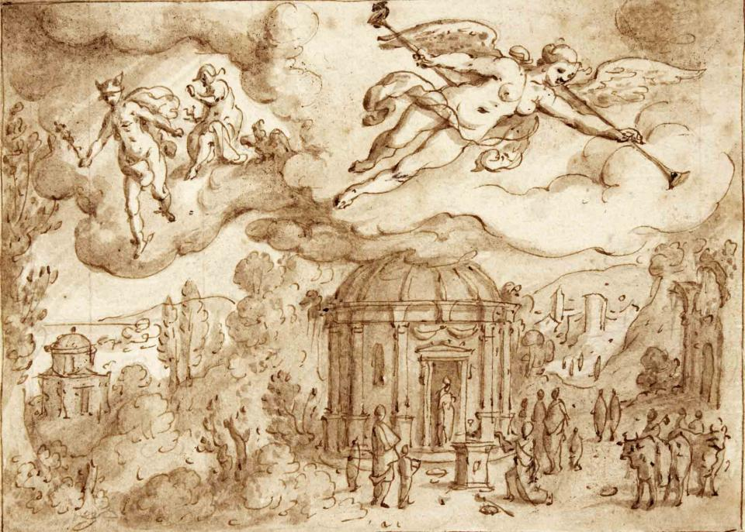

“Fama Tells the World of the Union of Dido and Aeneas and Jupiter Sends Mercury to Carthage.” Museum Plantin-Moretus, inv. PK.OT.02732. Image via The Frick Collection.

Course Description:

Ancient Rome gave us the most beautiful (in my biased opinion) literature we have. Roman authors built the foundation on which much of Western literature rests; their speeches, satires, and epics have inspired readers from Dante Alighieri to Toni Morrison. In this class, we will read the foundational texts of Latin literature—the writing of the ancient Romans—in genres from dirty love poetry to astronomy. We will examine these texts with an eye towards fundamental questions in the Roman imagination: what do we owe the gods? How should an emperor rule? What do you do when your friend has really, really bad breath? We will also consider what makes these texts, or any text, literature: we categorize texts based on ancient models, and understanding where these models come from makes us better readers and writers in our own right.

Required Texts:

· The Oxford Anthology of Roman Literature, by Peter Knox and J.C. McKeown (Oxford)
· Vergil, The Aeneid, translated by Barry Powell (Oxford)
· Ovid, Metamorphoses, translated by Charles Martin (Norton)

Classes:

While this class is in a lecture format, I ask a lot of questions. Please come in every day with a copy of the text at hand, and with opinions to share about the day’s reading. You will also be expected to participate in group work and other activities, as well as occasional short quizzes. I allow three unexcused absences per semester before your grade is affected; any more than that will require some kind of documentation (medical or otherwise).

I expect students to remain attentive and respectful at all times, particularly of each other. I cold call, which means that I will sometimes call on students who have not raised their hands; I know that can be tricky, and I expect all of you to help me create as comfortable a space for open dialogue as possible.

Given how important PDFs are to this class—and frankly, given the cost of printing—I understand and accept that students will be using devices in class. However, I prefer e-readers if possible, and ask that students disconnect their devices from the Internet during class. It is vital that you be fully engaged and present, and internet connectivity can hinder that engagement.

Students and faculty each have responsibility for maintaining an appropriate learning environment. Those who fail to adhere to such behavioral standards may be subject to discipline. Professional courtesy and sensitivity are especially important with respect to individuals and topics dealing with race, color, national origin, sex, pregnancy, age, disability, creed, religion, sexual orientation, gender identity, gender expression, veteran status, political affiliation or political philosophy. Class rosters are provided to the instructor with the student's legal name, but I will gladly honor your request to address you by an alternate name or gender pronoun. Please advise me of this preference early in the semester so that I may make appropriate changes to my records. For more information, see the policies on classroom behavior and the Student Code of Conduct.

Assignments, Exam, and Weekly Responses:

Over the course of the semester, you will write a short and a long paper. The short paper (3-5 pages, due March 3) will closely examine one of the texts we are reading, and the long paper (4-6 pages, due April 7) will compare two texts’ treatment of a specific problem or phenomenon. We will discuss these in more detail closer to their dates. There will also be a final exam for the course, scheduled for May 5, at 4:30 P.M.

Once a week (starting Week 2), I want you to upload a short (less than a page) response to the reading to Canvas. These don’t have to be formal; I just want you to tell me what you found interesting about the reading, and what you want to talk about. I use these to write my lectures; they are ungraded, but if you do not turn them in your participation grade will be affected. These are due at 3 P.M. the day before class.

Office Hours:

From 1:45 – 2:45 P.M. on Mondays and from 11:00 A.M. to noon on Tuesdays, I will be in my office (Woodbury 307) with the door open. I do this so that you can come by and talk to me about the class in a relaxed setting; whether you need help with something, have a question about the class, or simply want to talk more about the reading. Please come! You are always welcome to come to my office hours, and I appreciate the company. If you want to meet with me and are not free during my office hours, e-mail me at zachary.herz@colorado.edu and we can choose another time and place.

Grading Policy:

Your grades will be calculated as follows:

Participation: 15%
Weekly Responses: 10%
Short Paper: 15%
Long Paper: 25%
Midterm Exam: 10%
Exam: 25%

Academic Honesty:

All students enrolled in a University of Colorado Boulder course are responsible for knowing and adhering to the Honor Code. Violations of the policy may include: plagiarism, cheating, fabrication, lying, bribery, threat, unauthorized access to academic materials, clicker fraud, submitting the same or similar work in more than one course without permission from all course instructors involved, and aiding academic dishonesty. All incidents of academic misconduct will be reported to the Honor Code (honor@colorado.edu); 303-492-5550). Students who are found responsible for violating the academic integrity policy will be subject to nonacademic sanctions from the Honor Code as well as academic sanctions from the faculty member. Additional information regarding the Honor Code academic integrity policy can be found at the Honor Code Office website. Note that the rules around plagiarism and academic honesty are not always intuitive; if you are not sure how best to cite a source or what sort of attribution is appropriate, bring the source to office hours or make an appointment to discuss it. I am more than happy to help you comply with the rules and show you how best to do so. If in doubt, ask.

Disability and Accommodation:

If you qualify for accommodations because of a disability, please submit your accommodation letter from Disability Services to your faculty member in a timely manner so that your needs can be addressed. Disability Services determines accommodations based on documented disabilities in the academic environment. Information on requesting accommodations is located on the Disability Services website. Contact Disability Services at 303-492-8671 or dsinfo@colorado.edu for further assistance. If you have a temporary medical condition or injury, see Temporary Medical Conditions under the Students tab on the Disability Services website.

Sexual Misconduct, Discrimination, Harassment, and/or Related Retaliation

The University of Colorado Boulder (CU Boulder) is committed to fostering a positive and welcoming learning, working, and living environment. CU Boulder will not tolerate acts of sexual misconduct intimate partner abuse (including dating or domestic violence), stalking, protected-class discrimination or harassment by members of our community. Individuals who believe they have been subject to misconduct or retaliatory actions for reporting a concern should contact the Office of Institutional Equity and Compliance (OIEC) at 303-492-2127 or cureport@colorado.edu. Information about the OIEC, university policies, anonymous reporting, and the campus resources can be found on the OIEC website.

Please know that faculty and instructors have a responsibility to inform OIEC when made aware of incidents of sexual misconduct, discrimination, harassment and/or related retaliation, to ensure that individuals impacted receive information about options for reporting and support resources.

Religious Holidays:

Campus policy regarding religious observances requires that faculty make every effort to deal reasonably and fairly with all students who, because of religious obligations, have conflicts with scheduled exams, assignments or required attendance. In this class, I am more than happy to accommodate religious obligations but really really (no for real, really) need to know about them ASAP. Please look closely at the schedule of classes and let me know within the next two weeks if you will need to miss a class or exam for reasons of religious observance.

SCHEDULE OF CLASSES AND READINGS ON THE NEXT PAGE

PLEASE COMPLETE EACH ASSIGNMENT BEFORE THAT DAY’S CLASS

1/14 Introduction
No Assignment

1/16 Roman History, in a Day
No Assignment

1/21 Epic: Aeneid
Aeneid, Book 2

1/23 Epic: Aeneid
Aeneid, Book 4

1/28 Epic: Aeneid
Aeneid Book 4 (Bartsch/Zimmer trans.) (Canvas)

1/30 Epic: Metamorphoses
Metamorphoses, Book 1

2/4 Epic: Metamorphoses
Metamorphoses, Book 6

2/6 Epic: Lucan
OA 353-68

2/11 Philosophy: Lucretius
OA 73-85: ESSAY PROMPT 1 HANDED OUT

2/13 Philosophy: Marcus Aurelius
OA 591-99

2/18 Cicero, Defense Attorney/Sleazeball
OA 121-39

2/20 Cicero, Prosector/Fascist
OA 114-21

2/25 Poetry: Catullus, Dirtbag
OA 92-105

2/27 MIDTERM

3/3 Poetry: Propertius, Sad Boy
OA 244-55: ESSAY 1 DUE

3/5 Poetry: Ovid, The Saddest Boy of All
Ovidian Exile Poetry (Canvas)
3/10 Historiography: Sallust the Snob
OA 162-77: ESSAY PROMPT 2 HANDED OUT

3/12 Historiography: Tacitus, the Fancy Man
OA 459-79

3/17 Historiography: Suetonius, the Unauthorized Biographer
OA 498-513

3/19 Historiography: Scriptores Historiae Augustae, the ^%$$#(*&
SHA, Vita Elagabali (Canvas)

SPRING BREAK

3/31 Historiography: Plutarch, Where Every Story has a Moral
OA 521-35: ESSAY 2 DUE

4/2 Historiography: Cassius Dio, Ostrich Lover
Cassius Dio, Life of Commodus (Canvas)

4/7 Satire: Juvenal
Second Satire (Canvas): ESSAY 2 DUE

4/9 Satire: Martial
OA 442-50

4/14 Novels: Petronius’ Satyricon
OA 374-90

4/16 Novels: Apuleius’ The Golden Ass (not that ass) (kinda that ass)
OA 561-574

4/21 Novels: Let’s Go to the Moon!
Lucian, True Histories (Canvas)

4/23 Technical Literature: Medicine
Galen (Canvas)

4/28 Technical Literature: Law
Digest, Title I.1 (Canvas)

4/30 Reflections and Final Review

FINAL EXAM: MAY 5, 4:30 – 7:00 P.M.

