COLORADO UNIVERSITY BOULDER
DEPARTMENT OF CLASSICS
Spring 2020

CLAS/WGST 2110

GENDER AND SEXUALITY IN ANCIENT ROME

TTh 2:00 – 3:15 P.M. Zachary Herz, 307 Woodbury
201 Hellems zachary.herz@colorado.edu
Office Hours:
M 1:45 – 2:45
T 11:00 A.M. – 12:00 P.M.

Lukas Nicholson
lukas.nicholson@colorado.edu
Office Hours:
TBA

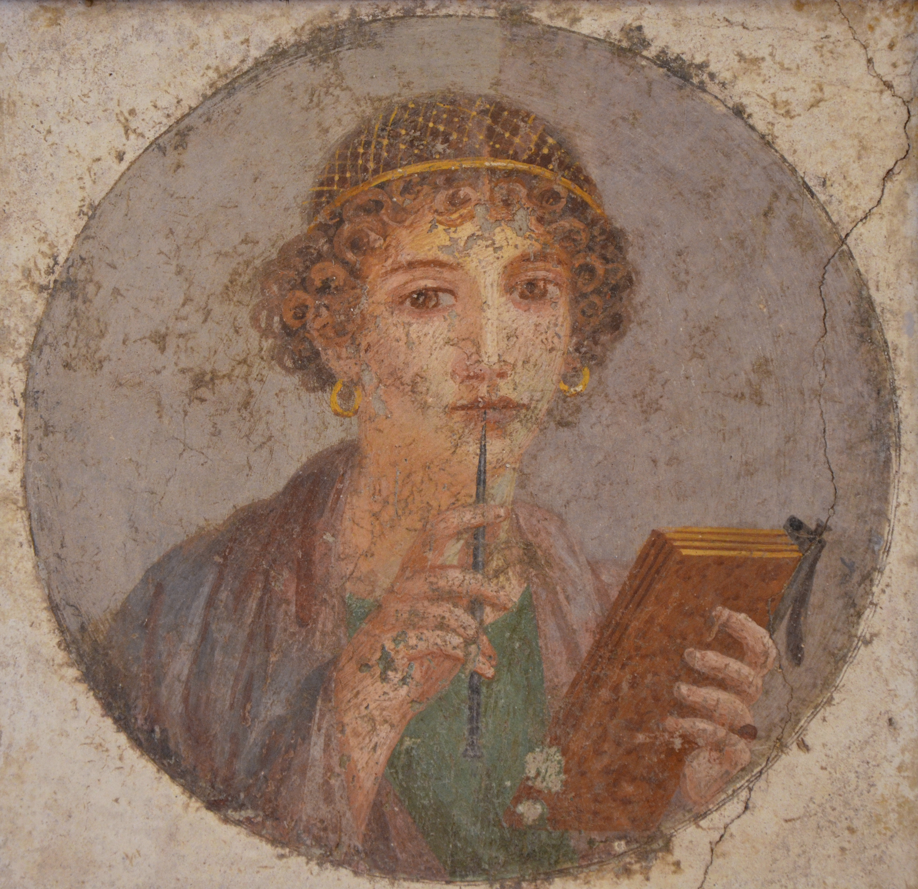

Fresco of a woman with book and stylus. Found in Pompeii; image via Wikimedia Commons.

Course Description:

Romans thought very hard about sex. Like most of us, they worried about the sex they were having or that they wanted to have, but they also organized their worlds around sex more broadly—around what it meant to be a man or a woman, and the social expectations that attached to each. In this class, we will examine Roman culture, society, and literature through the lens of sex and gender (i.e. the roles that men and women were expected to perform on the basis of their sex). Almost every question Romans faced—what makes a good leader? What is a good life? How is a person meant to be around others?—was a gendered one, and understanding the role gender norms played in the Roman mind will help us approach foundational questions in Roman history.

Required Texts:

While this class does not have a textbook, a number of the primary sources we will be reading are collected in the following sourcebook:

Bonnie MacLachlan, Women in Ancient Rome: A Sourcebook (Bloomsbury Academic Press, 2013).

This book is for sale at the university bookstore, and also at a number of fine retailers and websites posing as retailers. Buy it wherever you choose, but make sure you have the 2013 edition.

Classes:

While this class is in a lecture format, I ask a lot of questions. Please come in every day with a copy of the text at hand, and with opinions to share about the day’s reading. You will also be expected to participate in group work and other activities, as well as occasional short quizzes.

I expect students to remain attentive and respectful at all times, particularly of each other. I reserve the right to cold call, which means that I will sometimes call on students who have not raised their hands; I know that can be tricky, and I expect all of you to help me create as comfortable a space for open dialogue as possible.

Given how important PDFs are to this class—and frankly, given the cost of printing—I understand and accept that students will be using devices in class. However, I prefer e-readers if possible, and ask that students disconnect their devices from the Internet during class. It is vital that you be fully engaged and present, and internet connectivity can hinder that engagement.

Students and faculty each have responsibility for maintaining an appropriate learning environment. Those who fail to adhere to such behavioral standards may be subject to discipline. Professional courtesy and sensitivity are especially important with respect to individuals and topics dealing with race, color, national origin, sex, pregnancy, age, disability, creed, religion, sexual orientation, gender identity, gender expression, veteran status, political affiliation or political philosophy. Class rosters are provided to the instructor with the student's legal name, but I will gladly honor your request to address you by an alternate name or gender pronoun. Please advise me of this preference early in the semester so that I may make appropriate changes to my records. For more information, see the policies on classroom behavior and the Student Code of Conduct.

Written Work:

While this class does not require essays, I will ask you to write a reading response for one of the scholarly articles we read this semester. This response should be no more than two pages double-spaced, and should 1) summarize the article’s argument and 2) discuss how you feel it does or doesn’t inform your understanding of that day’s reading. These will be due on Canvas by midnight the night before the class for which that article is assigned; if you have any questions let me know.

Exams:

This course will have two midterms and a final. I will happily answer questions about those as we draw closer, but they will test comprehension of the class’s readings, understanding of lecture content, and ability to draw points that connect multiple sets of readings.

Office Hours:

On Mondays from 1:45 to 2:45 P.M. and on Tuesdays from 11:00 A.M. to noon, I will be in my office (Woodbury 307) with the door open. I do this so that you can come by and talk to me about the class in a relaxed setting; whether you need help with something, have a question about the class, or simply want to talk more about the reading. Please come! You are always welcome to come to my office hours, and I appreciate the company. If you want to meet with me and are not free during my office hours, e-mail me at zachary.herz@colorado.edu and we can choose another time and place.

Grading Policy:

Your grades will be calculated as follows:

Participation: 15%
Response: 10%
Midterm 1: 25%
Midterm 2: 25%
Final: 25%

Academic Honesty:

All students enrolled in a University of Colorado Boulder course are responsible for knowing and adhering to the Honor Code. Violations of the policy may include: plagiarism, cheating, fabrication, lying, bribery, threat, unauthorized access to academic materials, clicker fraud, submitting the same or similar work in more than one course without permission from all course instructors involved, and aiding academic dishonesty. All incidents of academic misconduct will be reported to the Honor Code (honor@colorado.edu); 303-492-5550). Students who are found responsible for violating the academic integrity policy will be subject to nonacademic sanctions from the Honor Code as well as academic sanctions from the faculty member. Additional information regarding the Honor Code academic integrity policy can be found at the Honor Code Office website. Note that the rules around plagiarism and academic honesty are not always intuitive; if you are not sure how best to cite a source or what sort of attribution is appropriate, bring the source to office hours or make an appointment to discuss it. I am more than happy to help you comply with the rules and show you how best to do so. If in doubt, ask.

Disability and Accommodation:

If you qualify for accommodations because of a disability, please submit your accommodation letter from Disability Services to your faculty member in a timely manner so that your needs can be addressed. Disability Services determines accommodations based on documented disabilities in the academic environment. Information on requesting accommodations is located on the Disability Services website. Contact Disability Services at 303-492-8671 or dsinfo@colorado.edu for further assistance. If you have a temporary medical condition or injury, see Temporary Medical Conditions under the Students tab on the Disability Services website.

Sexual Misconduct, Discrimination, Harassment, and/or Related Retaliation

The University of Colorado Boulder (CU Boulder) is committed to fostering a positive and welcoming learning, working, and living environment. CU Boulder will not tolerate acts of sexual misconduct intimate partner abuse (including dating or domestic violence), stalking, protected-class discrimination or harassment by members of our community. Individuals who believe they have been subject to misconduct or retaliatory actions for reporting a concern should contact the Office of Institutional Equity and Compliance (OIEC) at 303-492-2127 or cureport@colorado.edu. Information about the OIEC, university policies, anonymous reporting, and the campus resources can be found on the OIEC website.

Please know that faculty and instructors have a responsibility to inform OIEC when made aware of incidents of sexual misconduct, discrimination, harassment and/or related retaliation, to ensure that individuals impacted receive information about options for reporting and support resources.

Religious Holidays:

Campus policy regarding religious observances requires that faculty make every effort to deal reasonably and fairly with all students who, because of religious obligations, have conflicts with scheduled exams, assignments or required attendance. In this class, I am more than happy to accommodate religious obligations but really really (no for real, really) need to know about them ASAP. Please look closely at the schedule of classes and exams and let me know within the next two weeks if you will need accommodations for reasons of religious observance.

SCHEDULE OF CLASSES AND READINGS ON THE NEXT PAGE

PLEASE COMPLETE EACH ASSIGNMENT BEFORE THAT DAY’S CLASS

1/14: Introduction; Gender for Dummiez
No assignment

1/16: Roman History for Dummiez
No assignment

1/21 Introduction to Roman Comedy
WAR 74-78

1/23 Performance and Gender Play
Callier (Canvas)

1/28 Founding Mother: The Lucretia Myth and Women in Roman Patriotism
WAR 17-24

1/30 Roman Gay Dudes? Introducing the Cinaedus
Catullus 5, 16 (Canvas):* Kamen/Levin-Richardson (Canvas)

2/4 An Introduction to Roman Rhetoric; Cicero and Clodia
WAR 94-98, In Defense of Caelius (Canvas)

2/6 Horny for Tyranny: The Second Philippic
Against Marc Antony (Canvas); Fertik (Canvas)

2/11 MIDTERM 1!
No Assignment

2/13 Augustus and the Res Gestae
Res Gestae (Canvas); Milnor (Canvas)

2/18 Men Writing About Women
Horace (Canvas)

2/20 Sexual Violence in Roman Writing
Metamorphoses* (Canvas); Richlin (Canvas)

2/25 Sulpicia: A Woman in Her Own Words
WAR 148-50, Sulpicia (Canvas)

2/27 Dido, Queen of the Other
WAR 4-7; Keith (Canvas)

3/3 Bad Men, Bad Emperors
Suetonius (Canvas)

3/5 Elagabalus: Twink of the Sun
Vita Elagabali* (Canvas); Icks (Canvas)

3/10 Same-Sex Marriage?
Juvenal and Martial (Canvas)

3/12 Anachronism!!!
Richlin II, Williams (Canvas)

3/17 Women in Government
WAR 130-34

3/19 MIDTERM 2!
No Assignment

Spring break

3/31 Women in the Aristocracy
Martial (Canvas)

4/2 Women in Business
Laws About Women’s Power to Contract (Canvas); Dixon (Canvas)

4/7 The Laudatio Turiae
LT (Canvas); Osgood (Canvas)

4/9 Inscription v. Writing
WAR 156-161

4/14 Women and Death
Epigraphy (Canvas)

4/16 Ladies Be Suin’
Babatha Archive (Canvas)

4/21 The Age of Roman Women at Marriage
Hopkins, Shaw (Canvas)

4/23 Sumptuary Laws and Clothing
Images of Roman Fashion (Canvas)

4/28 Sex Work in the Roman World
Edwards (Canvas)

4/30 Final Review

Final Exam: Sunday, May 3, 4:30 – 7:00 P.M.

